

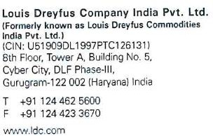**7th May 2021**

**Bharti Dubey**

M I G A 218, Mukharji Nagar, Vidisha, Madhya Pradesh.

**Dear Bharti Dubey,**

This refers to the discussions you had with us. We are pleased to offer you a position of **“Senior Developer RPA**” with Louis Dreyfus Company India Pvt. Ltd. in our **Gurgaon** office.

During the term of your employment with us, you will be paid a total Cost to the Company (CTC) of **INR 14,50,000.00** annually (including Provident Fund), for the period of your contract.

The Company may at its sole and exclusive discretion pay a bonus to you once a year, pro-rated from the eligible review period, wherefrom applicable withholding taxes shall be deducted. In addition, you will get medical cover for self and your family and other benefits as given to employees of the Company.

The detailed appointment letter with the complete terms and conditions will be handed over to you on the date of your joining with us. The services can be terminated by either party by giving 3 months’ notice or a sum equivalent to **3 months’ salary** in lieu thereof.

You will be on probation of 3 months, which may be extendable based on your performance feedback received from your manager. During probation period, the notice period applicable to you will be 1 month.

Kindly submit the following documents for our records on the day of your joining:

* Acceptance of Resignation and Relieving letter from your last companies, if applicable
* Education Certificates
* Passport Copy
* Pan Card Copy
* Proof of Residence

•

Please sign the duplicate copy of this letter as token of your acceptance and return it to us. We expect you to join us no later than **1st July 2021**. Kindly confirm your exact joining date within 7 days from the date of this letter. In case you are unable to join LDCI on the above mentioned date, LDCI reserves the right to withdraw the offer.

Your place of posting is presently at **Gurgaon** and may be transferred to any other location within LDCI, depending upon the discretion of the management.

We welcome you to the company and wish you a bright future. Thanking you,

**Yours faithfully,**

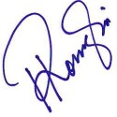

**Rosemary Kongari Assistant Manager – HR**

**Louis Dreyfus Company India Pvt. ltd. Acceptance**